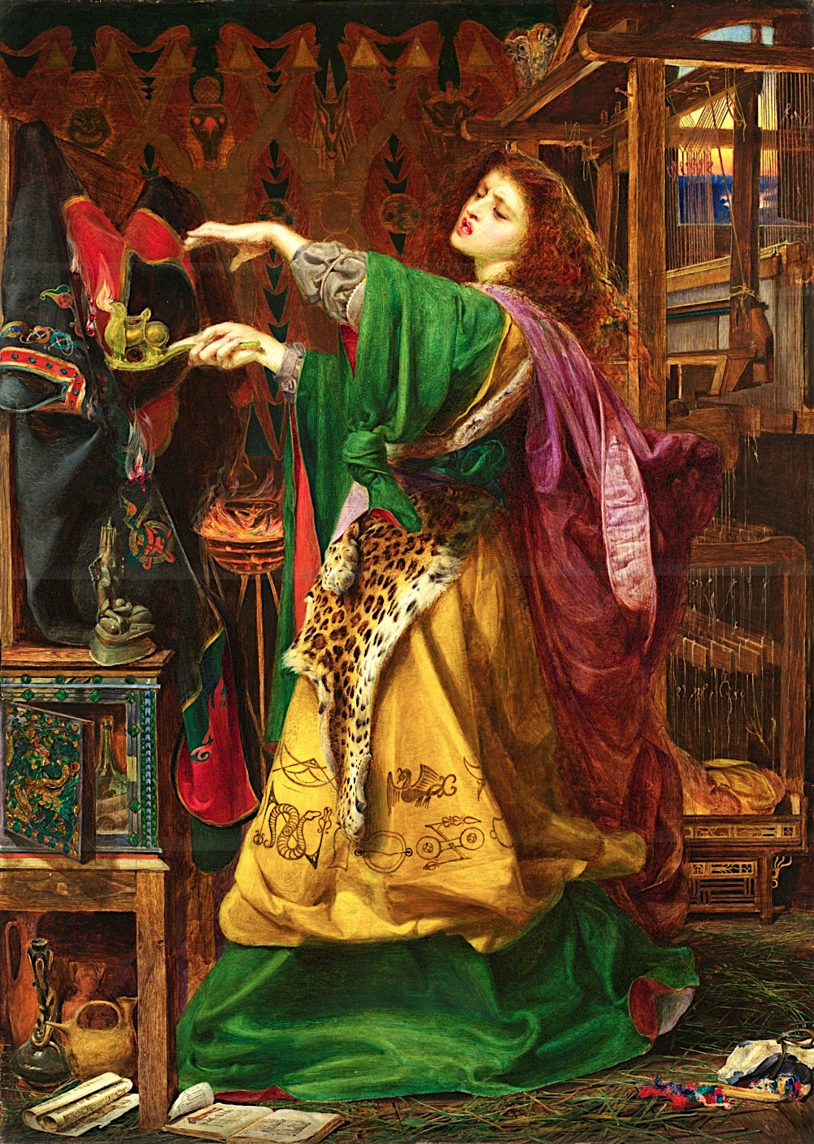
Morgane Le Fay

Written by Louis Gouëzel, Pierre d’Hébrail and Louis Ayasse

The destiny of the
last King

Once upon a time in the land of Fhang, Morgan, the dressmaker of the Naheulbeuk’s village, received an order for a kimono by Godefroy the Brave. He didn’t recognize her but she did: a long time before they were together. He had gone to the war and had come back on the arm of another woman. She had kept a vengeance sentiment. So she left her old life and went at the deep End of the world. She became a very powerful witch waiting for the time to come back in the land of Fhang. She was feeding a desire of revenge against the king who was actually her father and who has ruled her. A little by a little, she forgot the king and her ex-boyfriend. She came back home and became a dressmaker. Her isolation changed totally her figure and her spirit that no one recognized her.
So when she received this order, the wound opened again and she prepared her revenge. She will kill two birds with one stone. She made the greatest kimono that she could done during the day, and in the night, no one heard her send spells. In her trance, her eyes and her hair were reds and all the black power and her witchcraft got wild on the kimono. The devil himself was attacking the kimono by the fire. The dress didn’t take any damage proving that the kimono was resistant of the arrows and the swords. When Godefroy the Brave came and received his order, he wasn’t unto something. Exalting the beautiful work, the brave didn’t see Morgan laughing in one’s sleeve.
“- Do you want to try on it to know if it fits well to you? she asked with a bad hidden smile.
-By Jove! Sure! I want to be the most beautiful as I can!
- I’ll bring you a mirror during you’re getting change. “
Just at the moment he looked his reflection, the kimono flared but didn't burn and his eyes were full of blood and his voice became hoarse:
“- What do you want me to do, Venerated Mistress?
-Just remove this jewel of enchanting and you’ll put it when you’ll go to the king.
- But... Why?
- Don't speak to me and above all, don't ask me questions. Just do what I ask without think.
-Aye aye sir!”
She was gloating: she has this man under his orders, all that she said, he did it but as she can see, there was persisting some problems.
And when the knight removed the kimono, he forgot all what happened but he had an irresistible desire to put it in front of his Majesty the King. The more he came close of the king, the more this desire was big.
The day of the reception in the castle, a fabulous gust of wind crossed the house reversing all the potions and the olds books, not afraid at all, Morgan smiled: her new servant had put the kimono, the game was about to begin. She looked for her mirror, put it, closed the eyes reciting incantations. During ten interminable minutes, she was in trance. When she opened the eyes, the mirror changed of image. Now, there was the house of the knight in it: she was seeing trough the mirror what Godefroy was. She announced with a firm voice: "Go to the king and cope to sit next to him". Immediately, he went to the castle. No one saw in the alleys, the famous Brave walking by rote, the eyes full of blood. Fortunately, no one asked him in the hall.
The castle was a very important palace and when she saw it trough the mirror, the witch smiled again, seeing already her queen of this and of the entire kingdom. During the dinner, the king had an excellent time and his daughter a very bad one: the vision of his horrible man horripilate her. No one saw his neighbor who was not eating as the others, not laughing as the others, not feasting as the others. The king complimented him on his kimono to the noble but he turned the head looked at him and said very calmly: "You will die, son of a dog". The king laughed, thinking that he was drunk; he looked him again: Godefroy was looking his feet. This sentence, it's Morgan who had pronounced it. He stayed thus during all the plates. When the desserts came, he rose abruptly up and shouted: "NO". Everyone stopped eat, laugh, feast and looked at him. They all stayed thus, looking the man that had shouted. A little time after, without apologize, he turned and went to the kitchens. The murmur resumed and the music effaced this event.
What happened is more understandable if we go in Morgan's house. Morgan said to her mirror: "Kill the king". The knight screamed "NO" and Morgan who was stressed, overflowed: "What? How can you discuss my holies orders? I am the divine power: say more one thing and I will send a full army on you" She was knowing that she will not do that, not because she can't do that but because of this opportunity She roared her servant during the time he was standing. In this monolog to her mirror, she crushed his patriotic fervor, which came from the depths of his soul. At the end, she repeated much less calmly than last time: "Go to the kitchens, take a cut and KILL THE KING". She said those three last words with a wild voice.
So, the Brave came to the kitchen, take a cut and return to the king. He raised the cut and hesitated a few time. This time was fatal for him: the guards jumped to him and tried to stop him but he was unwavering. He downed the cut, checked his fact and left the castle, running by a supernatural power. All the cavalry rushed in pursuit of him but no one found him. When he arrived in the forest, he continued to run until exhaustion. He was totally hysterical and in his rage, he snatched the kimono. The bad spirits were swirling around him like vultures. His soul was fighting for not to the bad spirits catch his body. He was struggling against the army and the devil. In his head, all the memories came, the ideas were upset and then, he collapsed, abandoning. When Morgan saw his reflection in the mirror, she sneered seriously.
A few years ago, the kingdom was anarchic: Merlin couldn't choose a king and the throne, the castle were abandoned. A legend was spreading: it would have been a high dignitary of the king who had killed him but it was unbelievable. And in his house, Morgan was still laughing of her bad shot: she had kill one and the other would be stalking during all his life of poverty-stricken. She was preparing her plan of taking the throne and the power. She had succeed and the devil with her.
Suddenly, the door opened and a macabre figure showed in the embrasure: a beggar unclean, unearth, dressed in rags. His face was so dirty that we can't really know if it's a manor not. He looks a phantom with the storm behind him. But Morgan without witchcraft recognized him: Godefroy was back and not with very good intentions... Bizarrely she wasn't afraid anymore, she rose and sit on a chair, and set him in the eyes during a long long time but he didn't move, he didn't say anything, she she began:
"- I knew that you would come." She knew anything but she wanted to overawe him, but that didn't work: he retorted, interrupting her abruptly.
"- Because of you, I killed the greatest man that I ever knew..." His voice was hoarse almost incomprehensible like came from the depths of the earth as wild as a bear. She didn't know what to say.
"- It's regrettable but...
-Because of, the big wizard Merlin -Morgan shivered at this name- Merlin had sent a malediction on me.
- Because of you, I am the most shameful man of the entire kingdom...
- You can't understand that...
- BECAUSE OF YOU I AM NOW A RAGAMUFFIN, he shouted, so now, listen to me women... Are you a women or a devil? Because of you, all the calamities that you can't imagine have felt on me and... and...
- And you come to me to say that? All that I did was justice, I am the good side and I'm sure you remember. Remember, remember, is it my fault if you got married with this women? What did I do for that? But now, nothing will arrest me and I will take the throne...
- NO, you'll pay for your acts...
- Factus lapis est."
A lightning flowed out of her finger and petrified the "knight" and a tornado took the cadaver. During the night, she couldn't sleep because of a lot of nightmares: the spirits of the two gentlefolks came on to haunt her nights. She became crazy and went in the forest feeding on roots and wild berries, and if she's not dead, it's that she's still there. And if she's dead, her spirit and the Devil himself are haunting the forest.
Now, in 2014, nobody remembers the Morgan's history. Nobody knows how terrible her life was.

