Accords Majeurs
Do  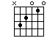 | Ré  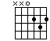 | Mi  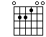 | Fa  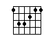
Sol  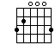 | La  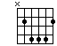 | Si  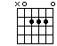

Accords Mineurs
Dom  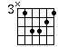 | Rém  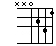 | Mim  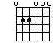 | Fam  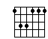
Solm  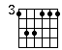 | Lam  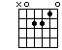 | Sim  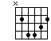

Accords Sus
Dosus  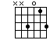 | Résus  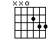 | Misus  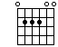 | Fasus  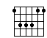
Solsus  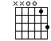 | Sol2sus  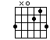 | Lasus  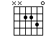 | Sisus  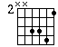

Accords 7eme
Do7  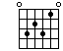 | Ré7  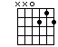 | Mi7  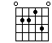 | Fa7  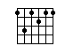
Sol7  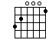 | La7  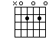 | Si7  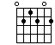

✓✓✓✓✓✓✓✓✓✓✓✓✓

Accords 7eme Major
Amaj7  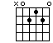 | Abmaj7  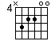 | Bmaj7  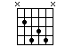 | Cmaj7  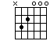
Dmaj7  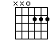 | Emaj7  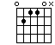 | Ebmaj7  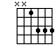 | Fmaj7  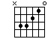
Gmaj7
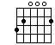

Accords 7eme Mineur
Am7  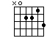 | Bm7  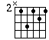 | Cm7  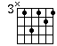 | C#m7  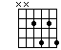
Dm7  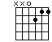 | Em7  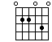 | Fm7  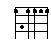 | F#m7  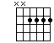
Gm7  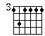 | G#m7  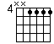

Accords 7eme Sus
A7sus  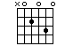 |  | B7sus  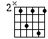 |  | C7sus  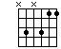 |  | D7sus  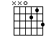
 | E7sus  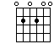 |  | F7sus  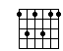 |  | G7sus  